
Our Ref: DA-872/2022
Contact: Customer Service
Ph: 02 8711 7975
Date: 16 October 2023

THE TRUSTEE FOR AGIVF CHIPPING NORTON TRUST
LEVEL 38 GATEWAY TOWER, 1 MACQUARIE PL
SYDNEY NSW 2000

NOTICE OF DETERMINATION OF DEVELOPMENT APPLICATION
ENVIRONMENTAL PLANNING AND ASSESSMENT ACT 1979

Pursuant to Section 4.16 of the Environmental Planning and Assessment Act 1979, Council has granted consent to your Development Application, described as follows:

APPLICANT: | THE TRUSTEE FOR AGIVF CHIPPING NORTON TRUST
LAND: | 24 ALFRED ROAD, CHIPPING NORTON NSW 2170, 30 ALFRED ROAD, CHIPPING NORTON NSW 2170  LOT 67 DP 17254, LOT B DP 386119, LOT A DP 386119, LOT 65 DP 17254
PROPOSED DEVELOPMENT: | Demolition Of The Existing Structures, Hardstand Areas, And Removal Of 9 Trees, Site Remediation And Earthworks, Construction Of Two Warehouses, Hardstand Area, 164 On-Site Car Parking Spaces, Landscaping Including The Planting Of 28 New Trees, Stormwater Management And Signage, Use Of The Site For Warehouse And Distribution Centres And Light Industries, With 24 Hour Operation
DETERMINATION: | Approved (Delegated Authority, Sydney Western City Planning Panel at its meeting of 16 October 2023)
CONSENT TO OPERATE FROM: | 16 October 2023
CONSENT TO LAPSE ON: | 16 October 2028
ATTACHMENTS: | - Conditions of Approval  - Section 7.12 Payment Form  - Sydney Water Requirements  - Endeavour Energy Requirements

Before commencing the development please read the Development Consent carefully and make sure you understand all the conditions that have been imposed. Please contact Council if you have any questions.

DEFINITIONS

AEP | Annual Exceedance Probability
Council | Liverpool City Council
DCP | Liverpool Development Control Plan 2008
DECC | Department of Environment and Climate Change and Water
CC | Construction Certificate
1% AEP Flood | The 1 in 100 year flood
EP&A Act | Environmental Planning and Assessment Act 1979
EP&A Regulation | Environmental Planning and Assessment Regulation 2021
LRS | Land Registry Services
NCC | National Construction Code (formerly Building Code of Australia)
OC | Occupation Certificate
PCA | Principal Certifying Authority
POEO Act | Protection of the Environment Operations Act 1997
TfNSW | Transport for NSW
TBA | To Be Advised

CONDITIONS
The following conditions have been imposed on the development to ensure all relevant planning requirements are met.
ATTACHMENT 1 – CONDITIONS OF APPROVAL

Council has imposed the following conditions under the relevant planning instruments and policies.

- THE DEVELOPMENT
Approved Plans

- Development the subject of this determination notice must be carried out strictly in accordance with the following plans/reports marked as follows, except where modified by the undermentioned conditions.

- Architectural Plans

Plan Name | Plan Number | Date | Revision | Prepared by
Cover Sheet and Drawing Schedule | DA00 | - | - | Watson Young
Demolition Plan | DA04 | 15.06.2023 | E
Site Plan | DA05 | 15.06.2023 | N | Watson Young
Proposed Floor Plan – Warehouse 1 | DA06 | 15.06.2023 | J | Watson Young
Proposed Floor Plan – Warehouse 2 | DA07 | 15.06.2023 | G | Watson Young
Roof Plan | DA08 | 15.06.2023 | F | Watson Young
Overall North & South Elevations and Sections | DA09 | 15.06.2023 | F | Watson Young
Warehouse 1 Elevations and Section | DA10 | 15.06.2023 | F | Watson Young
Warehouse 2 Elevations and Section | DA11 | 15.06.2023 | F | Watson Young
Warehouse 1 - Proposed Office Floor Plan | DA12 | 15.06.2023 | E | Watson Young
Warehouse 2 - Proposed Office Floor Plan | DA13 | 15.06.2023 | E | Watson Young
Pylon Signage Details | DA14 | 15.06.2023 | G | Watson Young
Landscape Cover Sheet | 000 | 04.05.2023 | I | Site Image Landscape Architects
Landscape Plan | 101 | 02.05.2023 | G | Site Image Landscape Architects
Landscape Plan | 102 | 02.05.2023 | G | Site Image Landscape Architects
Landscape Plan | 103 | 02.05.2023 | G | Site Image Landscape Architects
Landscape Plan | 104 | 02.05.2023 | G | Site Image Landscape Architects
Landscape Plan | 105 | 02.05.2023 | I | Site Image Landscape Architects
Landscape Plan | 501 | 27.05.2022 | C | Site Image Landscape Architects

- Civil Works Plans
Plan Name | Plan Number | Date | Revision | Prepared by
Civil Works Cover Sheet and Drawing List | 21-957.C000 | 09.06.2023 | P3 | AT&L Pty Ltd.
Legend and General Notes | 21-957.C001 | 09.06.2023 | P3 | AT&L Pty Ltd.
General Arrangements Plan | 21-957.C002 | 09.06.2023 | P3 | AT&L Pty Ltd.
Typical Sections | 21-957.C003 | 09.06.2023 | P3 | AT&L Pty Ltd.
Bulk Earthworks Plan | 21-957.C010 | 09.06.2023 | P3 | AT&L Pty Ltd.
Roadworks and Drainage Plan – Sheet 1 | 21-957.C021 | 09.06.2023 | P3 | AT&L Pty Ltd.
Roadworks and Drainage Plan – Sheet 2 | 21-957.C022 | 09.06.2023 | P3 | AT&L Pty Ltd.
Roadworks and Drainage Plan – Sheet 3 | 21-957.C023 | 09.06.2023 | P3 | AT&L Pty Ltd.
Roadworks and Drainage Plan – Sheet 4 | 21-957.C024 | 09.06.2023 | P3 | AT&L Pty Ltd.
Pavement Plan | 21-957.C030 | 09.06.2023 | P3 | AT&L Pty Ltd.
Sediment and Erosion Control Plan | 21-957.C040 | 09.06.2023 | P3 | AT&L Pty Ltd.
Sediment and Erosion Control Details | 21-957.C041 | 09.06.2023 | P3 | AT&L Pty Ltd.
Pervious Catchment Plan | 21-957.C050 | 26.05.2023 | P1 | AT&L Pty Ltd.

- Reports
Report Name | Date | Reference | Prepared by
Arboricultural Impact Assessment Report | 3 May 2022 | CEN22.2503, Rev. 2 | Lex Atkins
Noise and Vibration Report | 5 June 2023 | 610.30693-R01, Rev2 | SLR
Transport Assessment Report | 19 June 2023 | P1861, Rev. 5 | Ason Group
Flood Impact Assessment | 19 June 2023 | Issue A | J. Wyndham Prince
Civil Infrastructure Report | 16 June 2023 | REP001-03-20-957, Rev. 3 | AT&L Pty Ltd.
Detailed Site Investigation | 19 May 2022 | 62238/145405, Rev. 1 | JBS&G Australia Pty Ltd.
Remediation Action Plan | 3 June 2022 | 62238/145737, Rev. 0 | JBS&G Australia Pty Ltd.
Geotechnical Investigation | 18 March 2022 | PSM4578-005SL, Rev. 2 | Pells Sullivan Meynink (PSM)
Waste Management Plan | 6 June 2022 | S4622 WMP, Rev. 1 | Sustainable Development Consultants

Comply with EP&A Act

- The requirements and provisions of the Environmental Planning & Assessment Act 1979 and Environmental Planning & Assessment Regulation 2000, must be fully complied with at all times.

Failure to comply with these legislative requirements is an offence and may result in the commencement of legal proceedings, issuing of ‘on-the-spot’ penalty infringements or service of a notice and order by Council.

Works at no cost to Council

- All roadworks, drainage works and dedications, required to effect the consented development shall be undertaken at no cost to Liverpool City Council.

Prescribed condition

- In accordance with Section 4.16(11) of the Environmental Planning & Assessment Act 1979 and clause 98 of the Environmental Planning & Assessment Regulation 2000, it is a prescribed condition that all building work must be carried out in accordance with the applicable Performance Requirements of the National Construction Code. Compliance with the Performance Requirements can only be achieved by:
  - Complying with the Deemed to Satisfy Provisions; or
  - Formulating an Alternative Solution, which complies with the Performance Requirements or is shown to be at least equivalent to the Deemed to Satisfy Provision, or a combination of (a) and (b).

Use of Tenancies

- Further development consent is required should the following uses be proposed:

- Hazardous and Offensive Development
- Any use that gives rise to Odour emissions.
- Any use the gives rise to Noise not specified in the approved Acoustic report.
- Any use that gives rise to additional traffic movement outside the scope of the approved traffic report

- Sex Services
- Any other use that requires consent under another legislative instrument.

Agency Requirements
- All comments provided by Sydney Water shall be complied with prior, during, and at the completion of construction. A copy of the Sydney Water comments are attached to this decision notice, see Attachment 3.
- All comments provided by Endeavour Energy shall be complied with prior, during, and at the completion of construction. A copy of the Endeavour Energy comments are attached to this decision notice, see Attachment 4.

B. PRIOR TO ISSUE OF A CONSTRUCTION CERTIFICATE
The following conditions are to be complied with or addressed prior to the issue of a Construction Certificate by the Principal Certifying Authority.

- Section 7.12 Payment (Liverpool Contributions Plan 2018 – Established Areas) As a consequence of this development, Council has identified an increased demand for public amenities and public services. The following payment represents 1% of the cost of the development and is imposed in accordance with Section 7.12 of Liverpool Contributions Plan 2018 – Established Areas.

The total contribution is $500,639 and will be adjusted at the time of payment in accordance with the contribution plan.

A breakdown of the contributions payable is provided in the attached payment form.

The Contributions Plan may be inspected online at www.liverpool.nsw.gov.au

Payment must be accompanied by the attached form.

Notification

- The certifying authority must advise Council, in writing of:

- The name and contractor licence number of the licensee who has contracted to do or intends to do the work, or
- The name and permit of the owner-builder who intends to do the work.

If these arrangements are changed, or if a contact is entered into for the work to be done by a different licensee, Council must be immediately informed.

Any works constructed on private property will require the consent of the affected property owner.

Sustainability
- Prior to issue of a construction certificate the development shall make provisions for sustainability infrastructure within the development for the installation of the following measures to the satisfaction of the certifying authority. The measures are to future proof the development and ensures the development can be resilient.
  - Photovoltaic Solar systems; and
  - Electrical vehicle charging stations.

Provision of Services - Land Development
- An application to obtain a Section 73 Compliance Certificate under the Sydney Water Act 1994, must be lodged with Sydney Water. To facilitate this, an application must be made through an authorised Water Servicing Coordinator. Please refer to the “building and developing” section of Sydney Water’s web site at www.sydneywater.com.au, or telephone 13 20 92.
Following receipt of the application, a ‘Notice of Requirements’ will detail water and sewer extensions to be built and charges to be paid. Please make early contact with the Coordinator, since building of water/sewer extensions can be time consuming and may impact on other services and building, driveway or landscape design. A copy of the ‘Notice of Requirements’ must be submitted to the Principal Certifying Authority.

Provision of Services - Endeavour Energy

- Written clearance from Endeavour Energy, stating that electrical services have been made available to the development or that arrangements have been entered into for the provision of services to the development must be submitted to the Private Certifying Authority.

Provision of Services - Telco
- Prior to the issue of a Construction Certificate, the Principal Certifying Authority shall be satisfied that telecommunications infrastructure may be installed to service the premises which complies with the following requirements of the Telecommunications Act 1997:
- For a fibre ready facility, the NBN Co’s standard specifications current at the time of installation, and
- For a line that is to connect a lot to telecommunications infrastructure external to the premises, the line shall be located underground.
Unless otherwise stipulated by telecommunications legislation at the time of construction, the development must be provided with all necessary pits and pipes, and conduits to accommodate the future connection of optic fibre technology telecommunications.

Retaining Walls on Boundary
- All retaining walls shall be of masonry construction and must be wholly within the property boundary, including footings and agricultural drainage lines. Construction of retaining walls or associated drainage works along common boundaries shall not compromise the structural integrity of any existing structures.
Where a retaining wall exceeds 600mm in height, the wall shall be designed by a practicing structural engineer and a construction certificate must be obtained prior to commencement of works on the retaining wall.

S138 Roads Act – Minor Works in the public road
- Prior to the issue of a Construction Certificate, a Section 138 Roads Act application/s, including payment of fees, shall be lodged with Liverpool City Council, as the Roads Authority for any works required in a public road. These works may include but are not limited to:
- Vehicular crossings (including kerb reinstatement of redundant vehicular crossings),
- Road opening for utilities and stormwater (including stormwater connection to Council infrastructure), or
- Road occupancy or road closures.
All works shall be carried out in accordance with the Roads Act approval, the development consent including the stamped approved plans, and Liverpool City Council’s specifications.
Note: Approvals may also be required from the Roads and Maritime Service (RMS) for classified roads.

S138 Roads Act – roadworks requiring approval of civil drawings
- Prior to the issue of a Construction Certificate for building or subdivision works the Certifying Authority shall ensure that a S138 Roads Act application, including the payment of application and inspection fees, has been lodged with Liverpool City Council (being the Roads Authority under the Roads Act), for provision of 1.5m wide concrete footpath paving in Alfred Road site frontage.
Engineering plans are to be prepared in accordance with the development consent, Liverpool City Council’s Design Guidelines and Construction Specification for Civil Works, Austroad Guidelines and best engineering practice.
Note: Where Liverpool City Council is the Certifying Authority for the development the Roads Act approval for the above works may be issued concurrently with the Construction Certificate

S68 Local Government Act – Stormwater drainage works
- Prior to the issue of a Construction Certificate, the Principal Certifying Authority and/ or Certifying Authority shall ensure that an application under Section 68 of the Local Government Act, including the payment of application and inspection fees, has been lodged with, and approved by Liverpool City Council for connection of any private stormwater drainage into a public system.
Engineering plans are to be prepared in accordance with the development consent, Liverpool City Council’s Design Guidelines and Construction Specification for Civil Works and best engineering practice.

Site Development Work
- Site development work in the form of excavation, underpinning or shoring works must not take place, until such time as a CC has been issued.

Flood Management Requirements

- A detailed stormwater drainage design prepared by a qualified practicing civil engineer must be provided for assessment. The design shall align with the Concept Roadworks and Drainage Plan, Issue P3 dated 09/06/2023 and Civil Infrastructure Report dated June 2023 for 24 – 40 Alfred Road, Chipping Norton prepared by at&l and shall include all engineering details for collection and disposal of stormwater, existing site levels, finished levels, pipe sizes and grades and water quality treatment trains.

- On-site water quality treatment devices shall be provided to ensure that stormwater runoffs leaving the site comply with Council’s water quality standards. The treatment facilities shall capture all gross pollutants and liquid contaminants from the stormwater before discharging it to council’s stormwater network. Water quality treatment works shall be designed using MUSIC modelling software and the water quality treatment system performance shall be verified using Council’s MUSIC link.

- There shall be no net loss of floodplain storage volume below the 1% AEP flood. This includes but is not limited to a balanced cut and fill below the 1% Annual Exceedance Probability flood. A Cut and fill plan demonstrating no net loss of flood storage volume along with computation shall be provided for assessment.

- The lowest habitable floor level shall be no less than the 1% AEP flood plus half a metre freeboard (i.e. 6.0m + 0.5m = 6.50m Australian Height Datum).

- Non habitable and general industrial floor levels shall be no less than the 2% AEP flood.

- The structure shall be constructed from flood compatible building components below the 1% AEP flood plus half a metre freeboard (i.e. 6.0m + 0.5m = 6.50m Australian Height Datum).

- A site specific flood emergency response plan and flood evacuation plan shall be provided to council.

Substation
- Should the Electrical Substation be located outside the building envelope, the location and any associated fire separation walls must comply with Integral Energy Substation Design Instruction Document No SDI 104 (Current Version).

Products banned under the Building Products (Safety) Act 2017
- No building products that are banned, or products that are subject to a ban if used in a particular way under the Building Products (Safety) Act 2017 are to be used in the construction of the development.

Fire Safety Measures
- A schedule specifying all of the essential fire safety services, both existing and proposed, which are required for the building, shall be attached to the CC and submitted to Council, in compliance with the provisions of the EP&A Regulation.
The schedule must distinguish between the measures that are currently implemented (existing) in the building premises; and
- the measures that are to be proposed to be implemented in the building premises, and
- the minimum standard of performance for each measure.

Cladding
- Prior to issue of a construction certificate the certifier must be satisfied that all proposed attachments, cladding material and systems forming part of external walls comply with the NCC BCA and relevant Australian Standards. The certifier must be able to demonstrate compliance with evidence of suitability as per clause A2.2 of the BCA for all products/systems proposed.

Tree Protection Measures

- Tree protection measures are to be put in place in accordance with the recommendations of the tree report prepared by Lex Atkins dated: May 2022.

Recommendations of Acoustic Report
- The recommendations provided in the approved acoustic report titled (Report Title), report reference (Project Number/Job Number, Revision) prepared by (Author) dated (date) shall be implemented and incorporated into the design and construction of the development and be shown on plans accompanying the Construction Certificate application.
The construction methodology and plans accompanying the Construction Certificate application shall be assessed and certified in writing by a suitably qualified acoustic consultant to verify conformance with the requirements of the aforementioned acoustic report. The written certification from the suitably qualified acoustic consultant shall be submitted to and approved by the Principal Certifying Authority (PCA) prior to issue of the Construction Certificate.
Note: ‘Suitably qualified acoustic consultant’ means a consultant who possesses the qualifications to render them eligible for membership of the Australian Acoustical Society or employed by an Association of Australasian Acoustical Consultants (AAAC) member firm.

Construction Environmental Management Plan (CEMP)

- Prior to issue of a construction certificate, a Construction Environmental Management Plan (CEMP) for the development must be provided to the Principal Certifying Authority for approval. The environmental site management measures must remain in place and be maintained throughout the period of the development. The CEMP must address all environmental aspects of the development’s construction phases, and include (where relevant), but not be limited to, the following:
- Asbestos Management Plan;
- Project Contact Information;
- Site Security Details;
- Timing and Sequencing Information;
- Site Soil and Water Management Plan;
- Noise and Vibration Control Plan;
- Dust Control Plan;
- Air Monitoring;
- Odour Control Plan;
- Health and Safety Plan;
- Waste Management Plan;
- Incident management Contingency; and
- Unexpected Finds Protocol.
The CEMP must be kept on site for the duration of the works and must be made available to Council Officers upon request.

Stormwater Concept Plan
- A stormwater drainage system shall be provided generally in accordance with the concept plan/s lodged for development approval, prepared by AT&L reference number 21-957, revision P3 dated 09-06-2023.
- The proposed development and stormwater drainage system shall be designed to ensure that stormwater runoff from upstream properties is conveyed through the site without adverse impact on the development or adjoining properties.
- Engineering plans and supporting calculations for the stormwater drainage system are to be prepared by a suitably qualified engineer and shall accompany the application for a Construction Certificate. The plan shall indicate the method of disposal of all stormwater and must include rainwater tanks, existing ground levels, finish surface levels and sizes of all pipes.
- Prior to the issue of a Construction Certificate the Certifying Authority shall ensure that the stormwater drainage system has been designed in accordance with Liverpool City Council’s Design Guidelines and Construction Specification for Civil Works.
- All Easements to Drain water that currently burden the site are to be identified and no structures are permitted within or over them.
- Any existing stormwater drainage from the eastern properties that passes through the development site are to be maintained and/or incorporated into the site stormwater system, subject to any water quality requirements. Any required drainage easements are to be shown/created also and proposed foundations for structures adjoining the drainage are to be designed clear of the zone of influence.

No Loading on Easements
- Prior to the issue of a Construction Certificate the Certifying Authority shall ensure that the foundations of proposed structures adjoining the drainage and/ or services easement have been designed clear of the zone of influence.

Water Quality
- Prior to the issue of a Construction Certificate, the Certifying Authority shall ensure that details of a stormwater pre-treatment system have been provided on the stormwater plans and that the design meets pollutant retention criteria in accordance Council’s Development Control Plan.
The Construction Certificate must be supported by:
- Specification & installation details of the stormwater pre-treatment system
- The approval of an operation and maintenance manual/ schedule for the stormwater pre-treatment system
A copy of the approved operation and maintenance manual/ schedule shall be submitted to Liverpool City Council with notification of the Construction Certificate issue.

Inter-allotment Drainage
- Inter-allotment drainage shall be provided for all lots that are unable to be drained by gravity to the street system. Inter-allotment drainage is to be constructed with a pit located immediately within the lot boundary of each lot created by the subdivision at the lowest point in the line or a maximum pit spacing of 40m

Access, Car Parking and Manoeuvring – General
- Prior to the issue of a Construction Certificate the Certifying Authority shall ensure that vehicular access, circulation, manoeuvring, pedestrian and parking areas associated with the subject development are in accordance with AS 2890.1, AS2890.2, AS2890.6 and Liverpool City Council’s Development Control Plan.

Access, Car Parking and Manoeuvring – Detail
- The Certifying Authority shall ensure and certify that:
- Off street access and parking complies with AS2890.1,
- Vehicular access and internal manoeuvring have been designed for the longest (B-Double/ Heavy Rigid/ Medium Rigid) vehicle expected to service the development site, in accordance with AS2890.2,
- Sight distance at the street frontage has been provided in accordance with AS 2890.1,
- All vehicles can enter and exit the site in a forward direction, and/or Requirements of the Disability Discrimination Act 2002, Disability Standards for Accessible Public Transport and the Guidelines for assessing compliance of bus stops with the Disability Standards for Accessible Public Transport 2002.

Dilapidation report
- Prior to the Commencement of Works a dilapidation report of all infrastructure fronting the development in Alfred Road, Chipping Norton is to be submitted to Liverpool City Council. The report is to include, but not limited to, the road pavement, kerb and gutter, footpath, services and street trees and is to extend 20m either side of the development.

Vehicle Crossing and Existing Assets
- Prior to the issue of a Construction Certificate for building works arrangements shall be made with the relevant authority for the relocation of the asset/s affected by the proposed driveway vehicular crossing. Alternatively written acceptance regarding the proposed location of the vehicular crossing and the existing asset, and/or any alternative arrangements, shall be provided to the Principal Certifier. A copy of the written acceptance and/or their requirements is also to be provided to Council. All cost for any relocation to be at no cost to Council.

Construction Traffic Management Plan (CTMP)
- A construction traffic management plan (CTMP) prepared by a suitably qualified person is to be submitted to and endorsed by Council’s Transport Management Section. The CTMP is to be submitted using Assessment of Construction Traffic Management Plan application form. The application is available on Council website and can be lodged online. Comments on the CTMP will be provided and the updated CTMP are to be implemented during construction.
A copy of the endorsed CTMP and traffic control plans are to be available on the works site for inspection by authorised Council officers.
Construction shall not commence until the assessed construction traffic management plan has been endorsed. The endorsed CTMP is to be implemented during construction.

Mechanical Plant and Equipment

- Mechanical plant and equipment shall be selected in consultation with a suitably qualified acoustic consultant in accordance with the recommendations of the approved acoustic report titled titled “24-40 ALFRED STREET, CHIPPING NORTON Development Application Noise and Vibration Impact Assessment”, report reference (SLR Ref: 610.30693-R01 Revision v1.0) prepared by Adam Sirianni and reviewed by Antony Williams of SLR Consulting Australia Pty Ltd dated June 2022
Note: ‘Suitably qualified acoustic consultant’ means a consultant who possesses the qualifications to render them eligible for membership of the Australian Acoustical Society or employed by an Association of Australasian Acoustical Consultants (AAAC) member firm.

Waste Storage Area – Construction

- All waste management facilities shall comply with the Liverpool Development Control Plan 2008. Prior to the issue of a Construction Certificate, detailed floor and section plans shall be submitted to and approved by the Principal Certifying Authority for the waste storage area/s. The plans shall identify the location of the waste storage area/s and incorporate the following requirements:
- Sufficient space for access by residents, storage and easy manoeuvring of bins;
- The area is to be fully enclosed and include a solid roof and concrete or cement rendered walls coved to the floor;
- A concrete floor graded to an approved sewer connection comprising a sump and galvanised fine grade drain cover sufficient to prevent coarse pollutants from entering the sewer;
- Adequate ventilation to the external air by natural or mechanical means;
- The door to the room must be tight fitting and self-closing;
- A hose cock adjacent to the garbage storage area to facilitate cleaning of bins and the storage area. If the hose cock is located inside the waste storage area, it shall not protrude into the space indicated for the placement of bins;
- Sufficient lighting to permit usage at night; and
- Should garbage chutes be integrated into the design of the building, operational instructions shall be located prominently next to the chute.
Any modifications to the construction of the waste storage area require Council’s prior written Approval.

Detailed Traffic Design Drawings
- The applicant is to discuss with Council’s Traffic Management Section of the traffic requirements prior to undertaking the detailed design of traffic facilities, signs and linemarking in the existing and/or proposed public domain.
Detailed design drawings of the proposed traffic facilities, signs and line markings in the existing and proposed public domain areas are to be submitted to Council for approval using Approval of Traffic Facilities including Signs and Line Marking Schemes Application Form. The application is available on Council website and should be lodged online. The drawings are to be prepared by a suitably qualified person.
Street Lighting Upgrade
- The applicant/developer shall engage the services of an Endeavour Energy accredited ASP Level 3 service provider. The consultant is to lodge Endorsement of Public Lighting Design Application Form. The application is available on Council website and can be lodged online.
This form is to be used to seek Council requirements for upgrading or installing new street lights at all frontages.
Consult Council’s Traffic Management Section for streetlight upgrade requirement for infill developments in the existing established areas.
The upgrade shall include undergrounding of existing aerial power lines, communication cables and replacement of existing street light poles with Endeavour Energy approved Macarthur Poles as specified by Council in the public lighting design brief.

C. PRIOR TO WORKS COMMENCING
The following conditions are to be complied with or addressed prior to works commencing on the subject site/s:
Fee Payments

- Unless otherwise prescribed by this consent, all relevant fees or charges must be paid. Where Council does not collect these payments, copies of receipts must be provided. For the calculation of payments such as Long Service Levy, the payment must be based on the value specified with the Development Application/Construction Certificate.

The following fees are applicable and payable:

(a) Damage Inspection Fee – relevant where the cost of building work is $20,000 or more, or a swimming pool is to be excavated by machinery.

(b) Fee associated with Application for Permit to Carry Out Work Within a Road, Park and Drainage Reserve.

(c) Long Service Levy – based on 0.35% of the cost of building work where the costing of the CC is $25,000 or more.

These fees are reviewed annually and will be calculated accordingly

All fees associated with a road opening permit required for the connection, extension or amplification of any services within Council’s road reserve must be paid to Council and receipts provided to the PCA. A separate form must be submitted in conjunction with payment of the fees. The fees include the standard road opening permit fee and any restoration fees that may be required as a result of the works.

Demolition Works
- Demolition works shall be carried out in accordance with the following:
- Prior to the commencement of any works on the land, a detailed demolition work plan designed in accordance with the Australian Standard AS 2601-2001 – The Demolition of Structures, prepared by a suitably qualified person with suitable expertise or experience, shall be submitted to and approved by Council and shall include the identification of any hazardous materials, method of demolition, precautions to be employed to minimise any dust nuisance and the disposal methods for hazardous materials,
- Prior to commencement of any works on the land, the demolition Contractor(s) licence details must be provided to Council, and
- The handling or removal of any asbestos product from the building/site must be carried out by a NSW Work Cover licensed contractor irrespective of the size or nature of the works. Under no circumstances shall any asbestos on site be handled or removed by a non-licensed person. The licensed contractor shall carry out all works in accordance with NSW Work Cover requirements.

Waste Classification and Disposal of Contaminated Soil and Material

- All soils and material(s), liquid and solid, to be removed from the site must be analysed and classified by an appropriately qualified and certified consultant, in accordance with the Protection of the Environment Operations (Waste) Regulation 2014 and related guidelines, in particular the NSW EPA Waste Classification Guidelines, prior to off-site disposal.
All Waste material(s) must be disposed of at an appropriately licensed waste facility for the specific waste. Receipts for the disposal of the waste must be submitted to the Principal Certifying Authority within 30 days of the waste being disposed of.
All waste must be transported by a contractor licenced to transport the specific waste, and in vehicles capable of carting the waste without spillage, and meeting relevant requirements and standards. All loads must be covered prior to vehicles leaving the site.

Environmental Management

- Adequate soil and sediment control measures shall be installed and maintained. Furthermore, suitable site practices shall be adopted to ensure that only clean and unpolluted waters are permitted to enter Council’s stormwater drainage system during construction/demolition. Measures must include, as a minimum:
- Siltation fencing;
- Protection of the public stormwater system; and
- Site entry construction to prevent vehicles that enter and leave the site from tracking loose material onto the adjoining public place.

Tree Protection Measures
- Tree protection measures are to be monitored in accordance with the recommendations of the tree report prepared by Lex Atkins dated: May 2022

Notification/Principal Certifying Authority

- The applicant shall advise Council of the name, address and contact number of the Accredited Certifier, in accordance with Section 4.18 of the Act.

- The PCA must advise Council of the intended date to commence work which is the subject of the consent, by completing a notice of commencement of building works or subdivision works form, available from Council’s Customer Service Centre. A minimum notice period of two (2) working days must be given.

- Written notice of intention shall be given to the owners or the adjoining allotments of land, outlining the particulars of the work, which involves:

- Any excavation below the base of the footings of a building on an adjoining allotment of land.

- The notice shall be given seven (7) days prior to the commencement of work.

- In the event the development involves excavation that extends below the level of the base of the footings of a building on adjoining land, the following is to be undertaken at full cost to the developer:
- Protect and support the adjoining premises from possible damage from the excavation, and

- Where necessary, underpin the adjoining premises to prevent any such damage.

Site Notice Board

- A sign must be erected in a prominent position on the premises on which work is to be carried out. The sign is to be maintained during work, and removed at the completion of work. The sign must state:

(a) The name, address and telephone number of the principal certifying authority for the work; and
(b) The name of the principal contractor (if any) for any building work and a telephone number on which that person may be contacted outside working hours; and
(c) Unauthorised entry to the premises is prohibited.

Commencement of building works

- Building work shall not commence prior to the issue of a Construction Certificate. Building work as defined under Section 1.4 of the EP&A Act means any physical activity involved in the erection of a building and includes but is not limited to, the placement of any site shed/s or builders facilities, site grading, retaining walls, excavation, cutting trenches, installing formwork and steel reinforcement or, placing of plumbing lines.

Construction certificates

- Prior to the commencement of any building works, the following requirements must be complied with:

- Construction Certificate must be obtained from the Council or an accredited certifier, in accordance with the provisions of the Environmental Planning & Assessment Act 1979.
- Where a Construction Certificate is obtained from an accredited certifier, the applicant shall advise Council of the name, address and contact number of the Accredited Certifier, in accordance with Section 6.6 of the Act.
- A copy of the Construction Certificate, the approved development consent plans and consent conditions must be kept on the site at all times and be made available to the Council officers and all building contractors for assessment.
- A principal certifier must be appointed to carry out the necessary building inspections and to issue an occupation certificate; and
- The principal certifier must advise Council of the intended date to commence work which is the subject of this consent by completing a notice of commencement of building works or subdivision works form, available from Council’s Customer Service Centre. A minimum period of two (2) working days’ notice must be given.

Road works
- Works within the public road reserve shall not commence until the design drawings including the associated signs and line marking scheme have been approved by Council’s Traffic Management Section.

Work Zone
- A Works Zone application is required if on-street parking is affected with commuter parking and there is insufficient off-street parking space.
A Works Zone Application Form is available on Council website and can be lodged online by attaching all required documents indicated on the application form.

Traffic Control Plan
- Prior to commencement of works, a Traffic Control Plan including details for pedestrian management, shall be prepared in accordance with AS1742.3 “Traffic Control Devices for Works on Roads” and the Roads and Traffic Authority’s publication “Traffic Control at Worksites” and certified by an appropriately accredited Roads and Traffic Authority Traffic Controller.
Traffic control measures shall be implemented during the construction phase of the development in accordance with the certified plan. A copy of the plan shall be available on site at all times.
Note: A copy of the Traffic Control Plan shall accompany the Notice of Commencement to Liverpool City Council.

Road Occupancy Permit
- Road occupancy and road opening approvals will be required from Council to undertake works within the existing road reserve. The following applications are available on Council’s website and can be lodged online attaching all required documents indicated on the application form.
Road Occupancy Application Form
Road Opening Application Form

Sediment & Erosion Control

- Prior to commencement of works sediment and erosion control measures shall be installed in accordance with the approved Construction Certificate and to ensure compliance with the Protection of the Environment Operations Act 1997 and Landcom’s publication “Managing Urban Stormwater – Soils and Construction (2004)” – also known as “The Blue Book”.

The erosion and sediment control measures shall remain in place and be maintained until all disturbed areas have been rehabilitated and stabilised.

“DIAL BEFORE YOU DIG”

- Underground assets may exist in the area that is subject to your application. In the interest of health and safety and in order to protect damage to third party assets please contact Dial before you dig at www.1100.com.au or telephone 1100 before excavating or erecting structures (This is the law in NSW). If alterations are required to the configuration, size, form or design of the development upon contact the Dial before You Dig service, an amendment to the development consent (or a new development application) may be necessary. Individuals owe asset owners a duty of care that must be observed when working in the vicinity of plant or assets. It is the individual’s responsibility to anticipate and request the nominal location of plant or assets on the relevant property via contacting the Dial before you dig service in advance of any construction or planning activities.

D. DURING CONSTRUCTION
The following conditions are to be complied with or addressed during construction:
Hours of Construction Work and Deliveries

- All Civil Work, including the delivery of materials, is only permitted on the site between the hours of 7:00am to 6:00pm Monday to Friday and 8:00am to 1:00pm Saturday. No work will be permitted on Sundays or Public Holidays, unless otherwise approved by Council.
Construction/ Work Noise
- Construction noise or noise associated with any approved works shall not exceed the management levels defined within the Interim Construction Noise Guideline published by the NSW Department of Environment and Climate Change dated July 2009.

Major Filling/ Earthworks
- All earthworks shall be undertaken in accordance with AS 3798 and Liverpool City Council’s Design Guidelines and Construction Specification for Civil Works.
The level of testing shall be determined by the Geotechnical Testing Authority/ Superintendent in consultation with the Principal Certifying Authority
Dilapidation Report
- Any rectification works required by Council regarding the condition of Council infrastructure shall be undertaken, at full cost to the developer.
Erosion Control – Measures
- Prevent tracking of sediment or dirt onto adjoining roadways. Where any sediment is deposited on adjoining roadways shall be removed by means other than washing. All material is to be removed as soon as possible and the collected material is to be disposed of in a manner which will prevent is mobilisation.
- Erosion and sediment control measures shall remain in place and be maintained until all disturbed areas have been rehabilitated and stabilised.

General Site Works - Sediment
- The development, including construction, shall not result in any increase in sediment deposition into any water body, wetland, bushland or environmentally significant land.

Removal of dangerous and/or hazardous waste
- All dangerous and/or hazardous material shall be removed by a suitably qualified and experienced contractor licensed by SafeWork NSW. The removal of such material shall be carried out in accordance with the requirements of SafeWork NSW and the material shall be transported and disposed of in accordance with NSW Environment Protection Authority requirements.
Identification Survey Report

- The building and external walls are not to proceed past ground floor/reinforcing steel level until such time as the PCA has been supplied with an identification survey report prepared by a registered surveyor certifying that the floor levels and external wall locations to be constructed, comply with the approved plans, finished floor levels and setbacks to boundary/boundaries. The slab shall not be poured, nor works continue, until the PCA has advised the builder/developer that the floor level and external wall setback details shown on the submitted survey are satisfactory.

In the event that Council is not the principal certifier, a copy of the survey shall be provided to Council within three (3) working days.

- On placement of the concrete, works again shall not continue until the PCA has issued a certificate stating that the condition of the approval has been complied with and that the slab has been poured at the approved levels.

Contamination
- The development, including all civil works and demolition, must comply with the requirements of the Contaminated Land Management Act, 1997, State Environmental Planning Policy No. 55 – Remediation of Land, and Managing Land Contamination – Planning Guidelines (Planning NSW/EPA 1998).
Imported Fill Material
- Filling material must be limited to the following:
- Virgin excavated natural material (VENM)

- Excavated natural material (ENM) certified as such in accordance with Protection of the Environment Operations (Waste) Regulation 2014; and/or

- Material subject to a Waste Exemption under Clause 91 and 92 Protection of the Environment Operations (Waste) Regulation 2014 and recognised by the NSW Environment Protection Authority as being “fit for purpose” with respect to the development subject of this application.

Certificates proving that the material imported is ENM or VENM must be provided to the Principal Certifying Authority prior to filling. Certificates are to be provided to Council officers if and when requested.
Fill imported on to the site must be compatible with the existing soil characteristic for site drainage purposes.
Record Keeping of Imported Fill
- The following records of accepted waste derived fill material must be submitted to the Principal Certifying Authority at the completion of earth works:
- the course (including the address and owner of the source site), nature and quantity of all incoming loads including the date, the name of the carrier, and the vehicle registration,
- Documentation confirming the results of the waste classification assessment carried out on the fill material used in the development, and
- the results of any chemical testing undertaken on fill material.

Site Remediation Works
- The site must be remediated in accordance with;
- Remediation Action Plan titled Aliro Management Remediation Plan 24 and 30-40 Alfred Road Chipping Norton (Ref: 62238/145737 Rev0) prepared by Matthew Bennett of JBS&G, dated 3 June 2022;
- State Environmental planning Policy (Resilience and Hazards) 2021;
- National Environment Protection (Assessment of Site Contamination) Measure (ASC NEPM, 1999 as amended 2013); and
- The guidelines in force under the Contaminated Land Management Act 1997.
The applicant must engage an appropriately qualified and experienced environmental consultant to supervise all aspects of site remediation and validation works in accordance with the approved Remedial Action Plan.
Council must be informed in writing of any proposed variation to the remediation works. Council must approve these variations in writing prior to commencement/ recommencement of works.

Unidentified Contamination
- Any new information which comes to light during remediation, demolition or construction works which has the potential to alter previous conclusions about site contamination and remediation must be immediately notified to Council and the Principal Certifying Authority in writing.
A Section 4.55 Application under the EP&A Act shall be made for any proposed works outside the scope of the approved development consent.

Air Quality
- Dust screens shall be erected and maintained in good repair around the perimeter of the subject land during land clearing, demolition, and construction works.

Where operations involve excavation, filling or grading of land, or removal of vegetation, including ground cover, dust is to be suppressed by regular watering until such time as the soil is stabilised to prevent airborne dust transport. Where wind velocity exceeds five knots the Principal Certifying Authority may direct that such work is not to proceed.

All vehicles involved in the delivery, demolition or construction process departing from the property shall have their loads fully covered before entering the public roadway.

Erosion Control

- Vehicular access to the site shall be controlled through the installation of wash down bays or shaker ramps to prevent tracking of sediment or dirt onto adjoining roadways. Where any sediment is deposited on adjoining roadways is shall be removed by means other than washing. All material is to be removed as soon as possible and the collected material is to be disposed of in a manner which will prevent its mobilisation.

Water Quality
- All topsoil, sand, aggregate, spoil or any other material shall be stored clear of any drainage line, easement, water body, stormwater drain, footpath, kerb or road surface and there shall be measures in place in accordance with the approved erosion and sediment control plan.
Pollution Control - Truck Movements
- The loading and unloading of all vehicles associated with the development must be undertaken within the property boundary of the premises subject to this consent.
Measures must be implemented to prevent tracking of sediment by vehicles onto roads.
Vehicle loads must be covered when entering and exiting the site with material
Pollution Control – Site Operations

- Building operations such as brick cutting, mixing mortar and the washing of tools, paint brushes, form-work, concrete trucks and the like shall not be performed on the public footway or any other locations which may lead to water pollution.
Construction Noise, Vibration Assessment and Management Plan
- The approved site-specific Construction Noise, Vibration Assessment and Management Plan prepared in accordance with condition (B162) shall be implemented, adhered to and maintained at all times during the construction period.

Removal/ Decommissioning of Underground Petroleum Storage System

- Decommissioning of the unused underground storage tank shall be undertaken in accordance with the following:
- Protection of the Environment Operations (Underground Petroleum Storage Systems) Regulation 2014
- AS 4976-2008 (R2016) - UPSS Technical note: Decommissioning, Abandonment and removal of UPSS produced by NSW Department of Environment, Climate Change and Water, now known as Office of Environment and Heritage; and
- UPSS Technical note: Decommissioning, Abandonment and removal of UPSS by NSW Department of Environment, Climate Change and Water, now known as Office of Environment and Heritage
A Validation Assessment of the soils upon removal of the UPSS is to be undertaken by a suitably qualified and certified contamination consultant and a report submitted to Liverpool City Council to confirm that the site is suitable for the proposed use.
Security Fence
- A temporary security fence to WorkCover Authority requirements is to be provided to the property during the course of construction.
Note. Fencing is not to be located on Council’s reserve area
General Site Works – Surface contours

- Alterations to the natural surface contours must not impede or divert natural surface water runoff, so as to cause a nuisance to adjoining property owners.

Waste Management Plan
- The Waste Management Plan submitted to and approved by Council must be adhered to at all times throughout all stages of the development. Supporting documentation (receipts/dockets) of waste/recycling/disposal methods carried out, is to be kept and must be produced upon the request of Council or any other authorised officer.

Note: Any non-compliance with this requirement will result in penalties being issued.

Sign Notice Board

- A sign must be erected and maintained in a prominent position on the site, which contains the following details:
  - name, address, contractor licence number and telephone number of the principal contractor, including a telephone number at which the person may be contacted outside working hours, or owner-builder permit details (as applicable)
  - name, address and telephone number of the principal certifier
  - a statement stating that ‘unauthorised entry to the work site is prohibited”.

Excavation

- In the event the development involves an excavation that extends below the level of the base of the footings of a building, structure or work (including any structure or work within a road or rail corridor) on adjoining land, the person having the benefit of the development consent must, at the person’s own expense:

- Protect and support the building, structure or work from possible damage from the excavation, and
- where necessary, underpin the building, structure or work to prevent any such damage.
- a and b above does not apply if the person having the benefit of the development consent owns the adjoining land or the owner of the adjoining land has given consent in writing to that condition not applying.
- Retaining walls or other approved methods necessary to prevent the movement of excavated or filled ground, together with associated subsoil drainage and surface stormwater drainage measures, shall be designed strictly in accordance with the manufacturers details or by a practising structural engineer.

Toilet Facilities

- Toilet facilities must be available or provided at the work site and must be maintained until the works are completed at a ratio of one toilet plus one additional toilet for every 20 persons employed at the site. Each toilet must:
- be a standard flushing toilet connected to a public sewer, or

- be connected to an on-site effluent disposal system approved under the Local Government Act 1993, or

- be a temporary chemical closet approved under the Local Government Act 1993.

Craning and Hoardings

- If the work is likely to cause pedestrian or vehicular traffic in a public area to be obstructed or rendered inconvenient; or if craning of materials is to occur across a public or road reserve area, a separate Road Occupancy Certificate and/or Hoarding approval must be obtained from Liverpool City Council prior to undertaking the works.

- Lifting or craning materials over a public footway or roadway is not permitted unless a “B” class construction hoarding has been installed in compliance with work cover authority requirements.

Refuse Disposal

- Adequate refuse disposal methods and builders storage facilities shall be installed on the site. Builders’ wastes, materials or sheds are not to be placed on any property other than that which this approval relates to.

Car Parking Areas
- Car parking spaces and driveways must be constructed of a minimum two coat finish seal or better.
All parking spaces must be clear of obstructions and columns, permanently line marked and provided with adequate manoeuvring facilities.
The design of these spaces must comply with Council’s DCP 2008, and Australian Standard 2890.1 Parking Facilities – Off-Street Car Parking.
All car parking areas are to be appropriately line marked and sign posted in accordance with the Council approved stamped plans.
All customer/visitor/staff parking areas are to be clearly signposted limiting car parking for customers/visitors/staff only. The applicant is to cover the costs of installation and maintenance of the signage.
The on-site parking spaces shown in the approved plans must be identified in accordance with A.S.2890.1 Parking Facilities – Off-Street Car Parking.

Construction Noise and Vibration
- Noise and vibration associated with excavation, demolition and construction activities shall comply with the management levels detailed within the ‘Interim Construction Noise Guideline’ published by the Department of Environment and Climate Change NSW (DECC 2009/265) dated July 2009 and acceptable vibration values prescribed within the Environmental Noise Management Assessing Vibration: A Technical Guideline (Department of Environment and Conservation, 2006).
All feasible and reasonable noise and vibration mitigation measures shall be implemented and any activities which may exceed the construction noise management levels and vibration criteria shall be identified and managed in accordance with the approved Construction Noise, Vibration Assessment and Management Plan.

Drainage Connection
- Prior to the connection of private drainage to Council’s drainage system, an inspection is to be carried out by Liverpool City Council’s Development Engineering Unit. A fee will be charged in accordance with Council’s adopted Fees and Charges, and is to be paid prior to the inspection.

Public Domain Works
- All works within the road reserve, including the approved sign and line making scheme, are to be carried out by the applicant, at no cost to Council, in accordance with the TfNSW/RMS ‘Delineation Guidelines’.
Glass Reflectivity

- The Reflectivity index of glass used in the external facade of the building is not to exceed 20%. To restrict the reflection of sunlight from buildings to surrounding areas and buildings.

E. PRIOR TO ISSUE OF OCCUPATION CERTIFICATE
The following conditions are to be complied with or addressed prior to issue of either an Interim or Final Occupation Certificate by the Principal Certifier (PC):
Rectification of Damage

- Prior to the issue of an Occupation Certificate, any damage to Council infrastructure not identified in the dilapidation report, as a result of the development shall be rectified at no cost to Liverpool City Council.
Any rectification works within Alfred Road, Chipping Norton will require a Roads Act application. The application is to be submitted and approved by Liverpool City Council prior to such works commencing.

Works as executed - General
- Prior to the issue of an Occupation Certificate, works-as-executed drawings and compliance documentation shall be submitted to the Principal Certifying Authority in accordance with Liverpool City Council’s Design Guidelines and Construction Specification for Civil Works.
An original set of works-as-executed drawings and copies of compliance documentation shall also be submitted to Liverpool City Council with notification of the issue of the Occupation Certificate where Council is not the Principal Certifying Authority.

Liverpool City Council clearance – Roads Act/ Local Government Act
- Prior to the issue of an Occupation Certificate, the Principal Certifying Authority shall ensure that all works associated with a S138 Roads Act approval or S68 Local Government Act approval have been inspected and signed off by Liverpool City Council.

Certificates
- Prior to the issue of an Occupation Certificate, written certification from all relevant service providers that the telecommunications infrastructure is installed in accordance with the requirements of the Telecommunications Act 1997:
- For a fibre ready facility, the NBN Co’s standard specifications current at the time of installation, and
- For a line that is to connect a lot to telecommunications infrastructure external to the premises, the line shall be located underground.
Unless otherwise stipulated by telecommunications legislation at the time of construction, the development must be provided with all necessary pits and pipes, and conduits to accommodate the future connection of optic fibre technology telecommunications

- Details of critical stage inspections carried out by the principal certifying authority together with any other certification relied upon must be provided to Council with the occupation certificate.

Obtain occupation certificate for change of use
- The premises must not be utilised until an Occupation Certificate is issued by the Principal Certifier. A single and complete Fire Safety Certificate certifying the operation of all of the fire safety measures within the building must be submitted to Council with the Occupation Certificate.

Section 73 Sydney Water Certificate
- A Section 73 Compliance Certificate under the Sydney Water Act 1994 must be obtained for submission to the PCA prior to issue of Occupation Certificate

Cladding
- Prior to issuing an occupation certificate the principal certifier must be satisfied that suitable evidence has been provided to demonstrate that the external wall cladding material and system is consistent with the consent documentation, NCC and relevant Australian Standards.

Bonds
- A maintenance bond in the form of a bank guarantee or cash bond ($TBA), shall be lodged with Council. The bond shall cover maintenance and any damage to roads, drainage lines, public reserves or other council property or works required as a result of work not in accordance with Council’s standards, and /or development consent conditions. The bond will be held by Council for a minimum period of 12 months from the date of Council’s acceptance of final works.

Stormwater Compliance
- Prior to the issue of an Occupation Certificate, the Principal Certifying Authority shall ensure that the:
- Stormwater pre-treatment system/s,
- Overland flowpath works,
- Flood control works, and/or
- Have been satisfactorily completed in accordance with the approved Construction Certificate and the requirements of this consent,
- Have met the design intent with regard to any construction variations to the approved design, and
- Any remedial works required to been undertaken have been satisfactorily completed.
Details of the approved and constructed system/s shall be provided as part of the Works-As-Executed drawings.

Restriction as to User and Positive Covenant
- Prior to the issue of an Occupation Certificate a restriction as to user and positive covenant relating to the following shall be registered on the title of the property:
- Stormwater pre-treatment system/s,
- Overland flowpath works,
- Flood control works, and/or
The restriction as to user and positive covenant shall be in Liverpool City Council’s standard wording as detailed in Liverpool City Council’s Design and Construction Guidelines and Construction Specification for Civil Works.

Directional Signage
- Directional signage indicating the location of customer parking, “in” and “out”, crossings and directional arrows are to be provided in accordance with the Council approved stamped plans.

Footpaths
- Construction of 1.5m wide by 100mm thick (with one layer of SL72 reinforcing mesh) concrete path paving on one side of all residential access roads and both sides of all collector and distributor roads. Path paving will not be required in minor cul-de-sac with less than fifteen lots.
Stormwater System Requirements
- Prior to the issue of an Occupation Certificate the Principal Certifier shall ensure that the stormwater system:
- Have been satisfactorily completed in accordance with the approved Construction Certificate and the requirements of this consent.
- Have met the design intent with regard to any construction variations to the approved design.
- Any remedial works required to been undertaken have been satisfactorily completed.

Details of the approved and constructed system/s shall be provided as part of the Works-As-Executed drawings.

- Prior to the issue of an Occupation Certificate signage which is clearly visible from the public road shall be placed within the development site. The signage shall indicate where there are vehicular ingress and egress only points, with "Entry Only" or "No Entry" as appropriate, and clearly identify loading dock entry points.

- Where drainage lines are within the site for adjoining sites, a drainage easement shall be created in accordance with Council’s minimum widths as scheduled in Councils design specification for subdivisions (as amended). The drainage easement may not be extinguished or altered except with the consent of Liverpool City Council.

- Replacement/relocation of any existing street trees impacted by the proposed driveway to the satisfaction of Council.
Flood Management Requirements
- A flood evacuation plan shall be developed and maintained, including suitable warning systems, signage and exits, to ensure the safe evacuation of people during floods up to and including the Probable Maximum Flood.

Recommendations of Acoustic Report & Aircraft Noise Intrusion

- The development is located within the Australian Noise Exposure Forecast (ANEF) 20 or greater contour and may be impacted by aircraft noise. Upon completion of works and prior to the issue of an Interim or Final Occupation Certificate, written certification prepared by a suitably qualified acoustic consultant shall be submitted to and approved by the Principal Certifying Authority (PCA) prior to issue of an Interim or Final Occupation Certificate. The written certification prepared by the suitably qualified acoustic consultant shall confirm that the development meets the relevant provisions of Australian Standard AS 2021:2015 Acoustics – Aircraft noise intrusion – Building siting and construction with respect to interior noise levels.
Furthermore, the certification prepared by the suitably qualified acoustic consultant shall confirm that the development complies with all requirements and recommendations detailed within the approved acoustic report titled “24-40 ALFRED STREET, CHIPPING NORTON Development Application Noise and Vibration Impact Assessment”, report reference (SLR Ref: 610.30693-R01 Revision v1.0) prepared by Adam Sirianni and reviewed by Antony Williams of SLR Consulting Australia Pty Ltd dated June 2022
Note: ‘Suitably qualified acoustic consultant’ means a consultant who possesses Australian Acoustical Society membership or is employed by an Association of Australasian Acoustical Consultants (AAAC) member firm.

Validation Report

- Prior to issue of the occupation certificate a detailed Validation report must be submitted to the Principal Certifying Authority. The Report must be prepared in accordance with:
- NSW Contaminated Land Planning Guidelines (1998);
- Relevant EPA guidelines. In particular the Contaminated Land Guidelines – Consultants Reporting on Contaminated Land (NSW EPA 2020); and
- National Environmental Protection (Assessment of Site Contamination) Measure 1999 (as amended 2013).
The Validation Report must be prepared or reviewed and approved by a suitably qualified and experienced contaminated land consultant.
The report's cover or title page of the document shall include a personalised electronic seal for either the CEnvP(SC) or CPSS CSAM scheme.
The Validation report must verify that the land is suitable for the purposed use(s), and that the remediation and validation of the site has been undertaken in accordance with the approved Remedial Action Plan.
Note: ‘Suitably qualified and experienced contaminated land consultant’ means someone who is certified under either the Environment Institute of Australia and New Zealand’s Certified Environmental Practitioner (Site Contamination) Scheme (CEnvP(SC)) or the Soil Science Australia Certified Professional Soil Scientist Contaminated Site Assessment and Management (CPSS CSAM) Scheme.

Environmental Health

- Prior to the occupation or tenancy of any industrial unit spaces within the development, a separate development application is to be submitted to and approved by Liverpool City Council to use each industrial unit space once the proposed specific use is known.

Each industrial warehouse space may be a source of offensive noise and potentially impact upon human health and amenity. Each individual development application shall include (but not be limited to) an acoustic report prepared by a suitably qualified acoustic consultant in accordance with the NSW Environment Protection Authority’s ‘Noise Policy for Industry’ (2017). The cumulative effect of noise must be considered when assessing the impact upon receivers.

Where necessary, the report shall assess potential sleep disturbance and road traffic noise impacts in accordance with the NSW Environment Protection Authority’s ‘Noise Policy for Industry’ (2017) and ‘NSW Road Noise Policy’ prepared by the Department of Environment, Climate Change and Water NSW (DECCW NSW) dated March 2011. The project noise trigger levels for the proposed development shall be selected according to the most stringent intrusive or amenity criteria. If required, recommendations and noise control measures shall be specified to achieve compliance with the assessment criteria. The assessment shall be representative of all noise generating activities on-site including but not limited to mechanical plant, patrons, deliveries and motor vehicle movements.
When assessing noise levels at commercial or industrial premises, the noise level shall be determined at the most affected point on or within the property boundary. Alternatively, when gauging noise levels at residences, the noise level shall be assessed at the most affected point on or within the residential property boundary. Where necessary, sound levels shall be adjusted in accordance with NSW Environment Protection Authority’s guidelines for tonality, frequency weighting, impulsive characteristics, fluctuations and temporal content.
Note: ‘Suitably qualified acoustic consultant’ means a consultant who possesses Australian Acoustical Society membership or are employed by an Association of Australasian Acoustical Consultants (AAAC) member firm.
The report's cover or title page must confirm membership details or include a watermark for the relevant certification body.
Council is unable to recommend specific consultants or auditors.

G. CONDITIONS RELATING TO USE

Goods in Building

- All materials and goods associated with the use shall be contained within the building at all times.

Graffiti

- Any graffiti carried out on the property shall be removed, within 48 hours, at full cost to the owner/occupier of the site.

Unreasonable Noise and Vibration

- The proposed use of the premises and/or machinery and equipment installed must not give rise to offensive noise that interferes with the amenity of neighbouring properties. In the event that Council receives a complaint regarding excessive noise from any aspect of the activities conducted onsite, the person(s) in control of the premises shall at their own cost arrange for an acoustic investigation to be carried out (by a suitably qualified acoustic consultant who possesses Australian Acoustical Society membership or are employed by an Association of Australasian Acoustical Consultants (AAAC member firm)) and provide a report specifying proposed methods for control of noise emanating from the premises. Any attenuation recommendations approved by Council must be implemented.
Waste Collection

- All solid waste stored on site is to be covered at all times. Furthermore, all solid and liquid waste is to be removed from the site by a registered waste contractor.

Waste Management

- Waste and recyclable material generated from the operations of the premises shall be managed in a satisfactory manner that does not give rise to offensive odour or encourage pest activity. All waste material shall be regularly removed from the premises. Waste shall not be permitted to accumulate near the waste storage bins.

Waste

- All waste materials generated as a result of the development are to be disposed at a facility licensed to receive such waste.

Waste Storage Area
- Waste bins must be stored in designated garbage/ trade refuse areas, which must be kept tidy at all times. Bins must not be stored or allowed to overflow in parking or landscaping areas, must not obstruct the exit of the building, and must not leave the site onto neighbouring public or private properties.
Operation, maintenance and cleaning of the garbage compactor and associated equipment is the responsibility of the strata management or body corporate. Maximum compaction ratio is 2:1.
Operation, maintenance and cleaning of the garbage chutes and associated waste cupboards, rooms, or equipment is the responsibility of the strata management or body corporate.
Signage is to be prominently displayed in each waste storage area, or waste service room, as appropriate, indicating that:
- Garbage is to be placed wholly within the garbage bins provided,
- Only recyclable materials accepted by Council are to be placed within the recycling bins,
- The area it to be kept tidy,
- A phone number for arranging disposal of bulky items, and
- Graphic illustrative content to be 50%.

Parking Spaces – Assessment Planner
- The following parking spaces should be used solely for the purpose it has been provided.
- Unrestricted resident car parking
- Visitor car parking
- Accessible car parking
- Motorcycle parking
- Cycle parking
- Delivery area
- Garbage pick-up area
- Washing bay

Car Parking Management
- All parking areas shown on the approved plans must be used solely for this purpose.

Hours of Operation

- The hours of operations are limited to:

  - Monday to Friday: 12:00 am to 11:59 pm.

  - Saturday to Sunday 12:00am to 11.59 pm.

Advisory Note - Restriction of Use to Operate:

As imposed under Condition 5 and 115 related to future use of tenancies.

Delivery hours and vehicles
- Delivery and service vehicles generated by the development are limited to:

  - Monday to Friday: 6:00am to 6:00pm;
  - Saturday 7:00am to 12:00pm.

Environment

- The use of the premises shall not give rise to the emission into the surrounding environment of gases, vapours, dusts or other impurities that are a nuisance, injurious or prejudicial to health.

Car Parking/Loading

- A total of 164 car parking spaces must remain onsite and are not to be utilised for storage of goods, trailers, containers and alike, and must not be enclosed under any circumstances.

Vehicle Access
- Vehicles entering or leaving the development site should be in forward direction, if practicable.

Dilapidation Report
- Any rectification works required by Council regarding the condition of Council infrastructure shall be undertaken, at full cost to the developer.

Industrial
- Driveways and car parking spaces must not be used for manufacture, storage or display of goods, materials or equipment. The spaces must be available at all times for all cars associated with the development.
- The premises must not be used for the display or sale of goods to the public (i.e., a shop).

General Site Operations
- All loading and unloading operations shall be carried out wholly within the confines of the site, at all times.

- All vehicles shall enter and leave the site in a forward direction.

- Visitor parking spaces must not be allocated, sold or leased to an owner, occupier or any other person or entity. In any strata subdivision, visitor parking spaces must be retained within the common property.

Lighting

- Illumination of the site is to be arranged in accordance with the requirements and specifications of Australian Standard 4282:2019 so as not to impact upon the amenity of the occupants of adjoining and nearby premises.

Noise - Silent Alarm System

- Any alarm installed on the site is to be “silent back to base” type.

Forklifts and Delivery Vehicles

- To minimise potential noise impacts, all forklifts and delivery vehicles associated with the use shall be equipped with smart (self-adjusting) reverse alarms, broadband reverse alarms, combination alarms or other suitable noise reduction technologies instead of tonal reversing alarms.

Loading Areas
- All loading and unloading must take place from the designated loading dock/bay. This area is to be clearly marked/signposted for use by delivery vehicles only.

Smoke-free Environment Act and Smoke-free Environment Regulation

- The Applicant and Occupier of the premises are alerted to the requirements of the Smoke-free Environment Act 2000 and Smoke-free Environment Regulation 2016. Nothing in this consent is to be taken to imply that the development meets the requirements of the aforementioned legislation. In the event that the Applicant and/or Occupier wishes to facilitate smoking within the premises, they must ensure that the design and construction of the area proposed to facilitate smoking fully complies with the requirements of the Smoke-free Environment Act 2000 and Smoke-free Environment Regulation 2016.

Complaints Handling Register

- A Complaints Handling Register shall be prepared and maintained for the operation of the development. The Complaints Register must be kept by the occupier, person carrying on the activity or other suitable staff members and include the following:
- the date and time, where relevant, of the complaint;
- the means by which the complaint was made (telephone, mail or email);
- any personal details of the complainant that were provided, or if no details were provided, a note to that effect;
- the nature of the complaint;
- any action(s) taken in response to the complaint, including any follow-up contact with the complainant;
- if no action was taken in relation to the complaint, the reason(s) why no action was taken; and
- allocate an individual “complaint number” to each complaint received.

The Complaints Register must be made available for inspection when requested by Liverpool City Council’.
Any public address system and/or amplified sound equipment shall be installed and operated so as not to cause ‘offensive noise’ as defined by the Protection of the Environment Operations Act 1997.

H. ADVISORY
- Section 4.53 of the EP&A Act provides that unless otherwise stated by a condition of this consent, this consent will lapse if development is not physically commenced within five years of the date of this notice.

- Section 8.2 of the EP&A Act provides that an applicant may request, within six (6) months of the date of the determination of the Development Application, that Council review its determination (this does not relate to designated development or Crown development).

An application under Section 8.2 of the EP&A Act cannot be reviewed/determined after 6 months of the date of determination. Therefore, the submission of a Section 8.2 Application must allow sufficient time for Council to complete its review within the prescribed timeframe, including the statutory requirement for public notification.

- Section 8.7 of the EP&A Act provides that an applicant who is dissatisfied with the determination of a Development Application, may appeal to the Land and Environment Court within six (6) months of the date of determination, or as otherwise prescribed by the EP&A Act.

- Section 8.8 of the EP&A Act provides that an objector who is dissatisfied with the determination of the consent authority to grant consent to a Development Application for Designated Development (including any State significant development that would be designed development but for Section 4.10(2) of the EP&A Act), may, within 28 days after the date on which the application is taken to have been determined, appeal to the Land and Environment Court, against the determination.

- The Commonwealth Disability Discrimination Act 1992 may apply to this proposal. Approval of this application does not imply or infer compliance with this Act. Applicants and owners are required to satisfy themselves as to compliance and make their own enquiries to the Human Rights and Equal Opportunity Commission. Attention is also drawn to the provisions of Australian Standard 1428 – Design for Access and Mobility.

- The requirements of all authorities including the Environmental Protection Authority and the Work Cover Authority shall be met in regard to the operation of the building.

- “DIAL BEFORE YOU DIG”

Underground assets may exist in the area that is subject to your application. In the interest of health and safety and in order to protect damage to third party assets please contact Dial before you dig at www.1100.com.au or telephone 1100 before excavating or erecting structures (This is the law in NSW). If alterations are required to the configuration, size, form or design of the development upon contact the Dial before You Dig service, an amendment to the development consent (or a new development application) may be necessary. Individuals owe asset owners a duty of care that must be observed when working in the vicinity of plant or assets. It is the individual’s responsibility to anticipate and request the nominal location of plant or assets on the relevant property via contacting the Dial before you dig service in advance of any construction or planning activities.

- TELECOMMUNICATIONS ACT 1997 (COMMONWEALTH)

Telstra (and its authorised contractors) are the only companies that are permitted to conduct works on Telstra’s network and assets. Any person interfering with a facility or installation owned by Telstra is committing an offence under the Criminal Code Act 1995 (Cth) and is liable for prosecution. Furthermore, damage to Telstra’s infrastructure may result in interruption to the provision of essential services and significant costs. If you are aware of any works or proposed works which may affect or impact on Telstra’s assets in any way, you are required to contact: Telstra’s Network Integrity Team on Phone Number 1800 810 443.

- The Liverpool City Council Local Government area soils and ground water may be subject to varying levels of Salinity. Whilst Council may require applicants to obtain Salinity reports relating to some developments, no assessment has been made by Council. Soil and ground water salinity levels can change over time due to varying factors. It is recommended that all applicants make their own independent inquiries as to appropriate protection against the current and future potential affect of Salinity to ensure the ongoing structural integrity of any work undertaken. Liverpool City Council will not accept any liability for damage occurring to any construction of any type affected by soil and or ground water Salinity.

- Care shall be taken by the applicant and the applicant’s agents to prevent any damage to adjoining properties. The applicant or applicant’s agents may be liable to pay compensation to any adjoining owner if, due to construction works, damage is caused to such an adjoining property.

- Letter boxes must be provided in accordance with the requirements of Australia Post. In this regard, the developer is required to obtain approval from Australia Post for letter box positioning and dimensions.

- The cost of any necessary adjustments to utility mains and services shall be borne by the applicant.
If you have any further enquiries, please contact Nabil Alaeddine on the abovementioned contact details.

Nabil Alaeddine
PRINCIPAL PLANNER
DEVELOPMENT ASSESSMENT

ATTACHMENT 2 - Section 7.12 Payment Form
CONTRIBUTIONS PURSUANT TO SECTION 7.12 OF THE ENVIRONMENTAL
PLANNING & ASSESSMENT ACT, 1979
Liverpool Contribution Plan 2018 - Established Areas
Note to the applicant: When remitting payment as specified in the Conditions of Consent to the approval, this Form must be submitted with your payment.
These figures have been calculated to the current CPI and will be adjusted at the time of payment in accordance with the conditions of consent.
APPLICATION NO: DA-872/2022

APPLICANT: The Trustee for AGIVF Chipping Norton Trust
PROPERTY: 24-30 Alfred Road, Chipping Norton
Lot A DP 386119, Lot B DP 386119, Lot 65 DP 17254 and Lot 67 DP 17254
PROPOSAL: | Demolition of the existing structures, hardstand areas, and removal of 9 trees, site remediation and earthworks, construction of two warehouses, hardstand area, 164 on-site car parking spaces, landscaping including the planting of 28 new trees, stormwater management and signage, use of the site for warehouse and distribution centres and light industries, with 24 hour operation

Transport - Bikeways - works
Eastern | $37,548 | GL.10000001865.10208
Transport - Traffic management - works
Eastern | $250,319 | GL.10000001865.10214
Transport - Bus shelters - works
Eastern | $12,516 | GL.10000001865.10216
Drainage - works
Eastern | $200,256 | GL.10000001866.10210
Total | $500,639

RECORD OF PAYMENT

Total Amount paid: ______________________________Date:________________________
Receipt No.:_____________________________Cashier:_____________________
ATTACHMENT 3 - Sydney Water Requirements
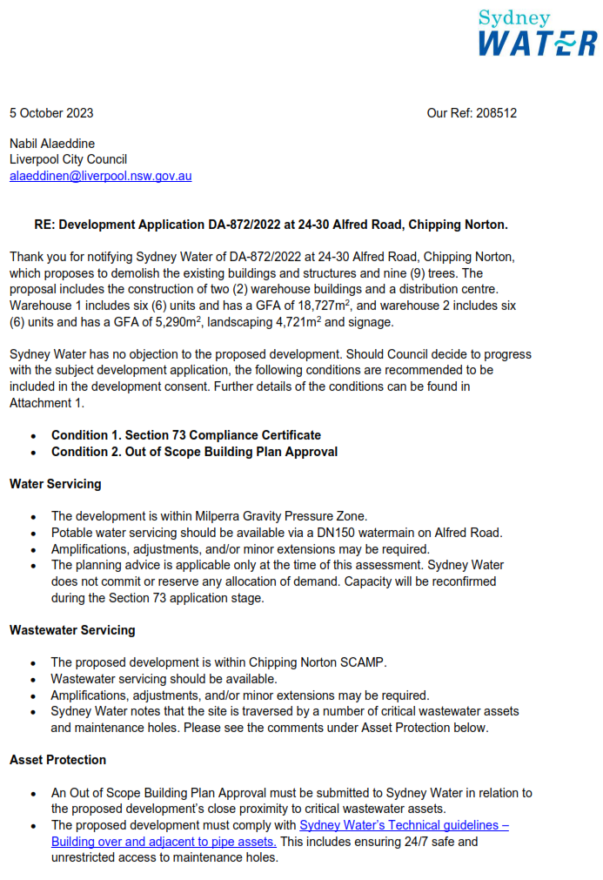
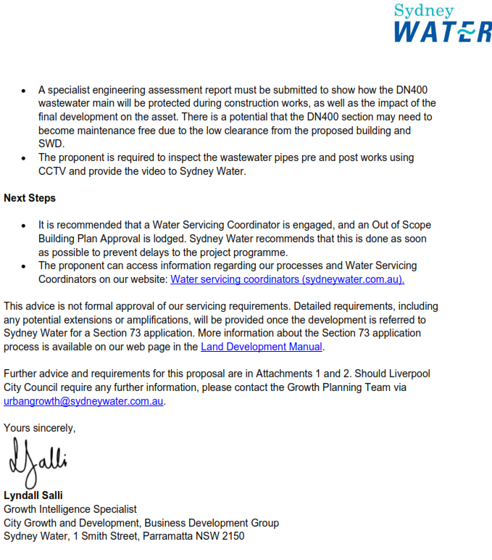
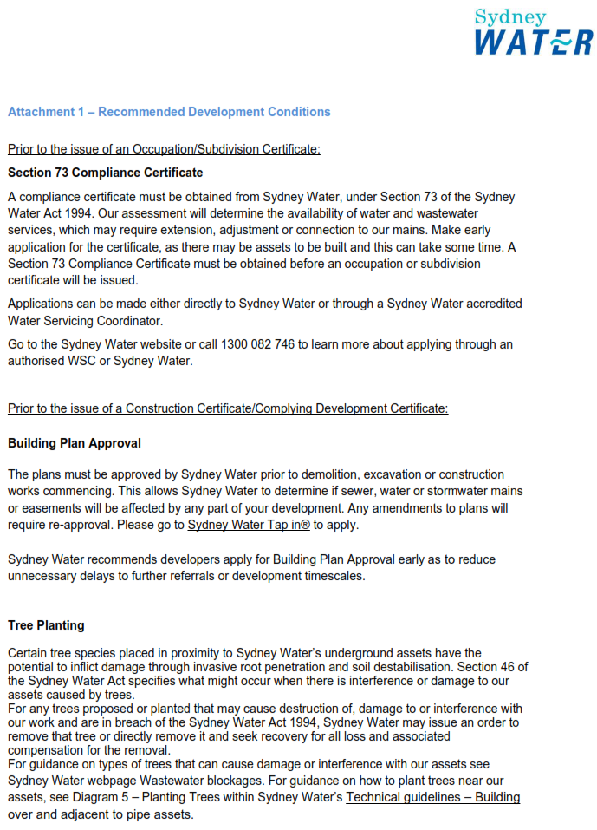
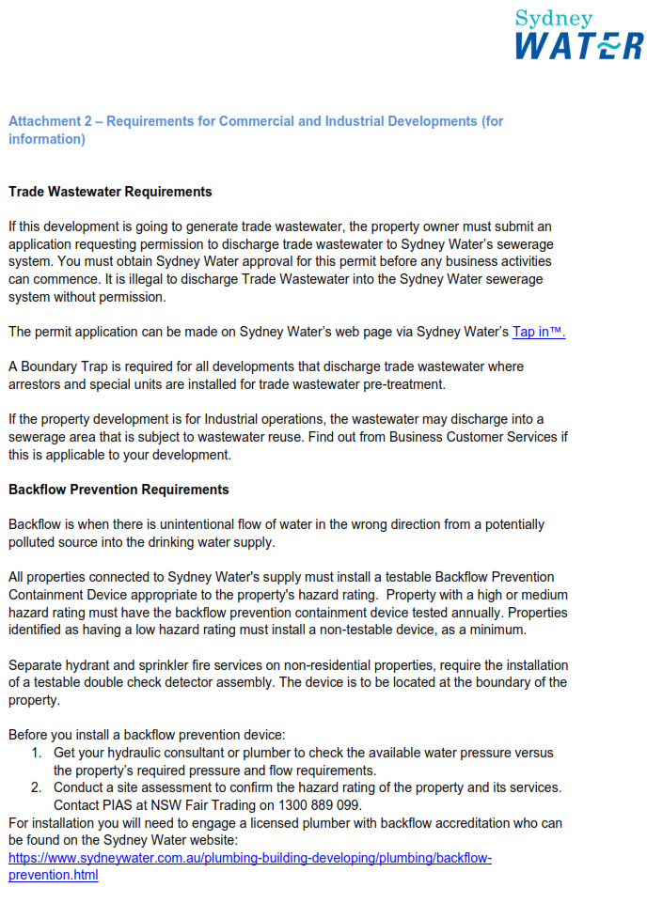
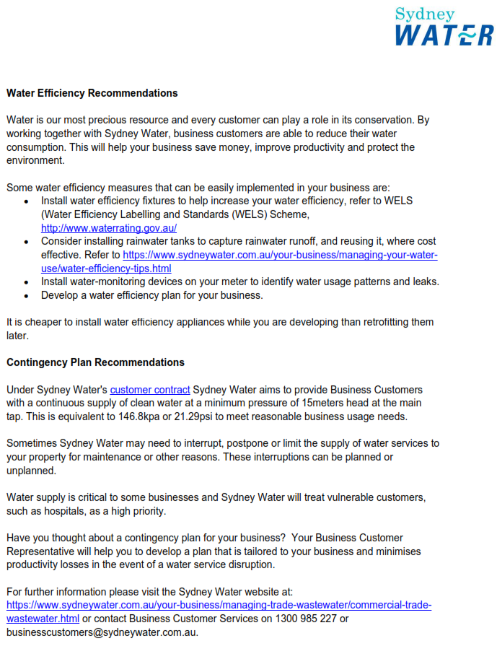
ATTACHMENT 4 - Endeavour Energy Requirements
